**RESULTS**

**GRAPH:**

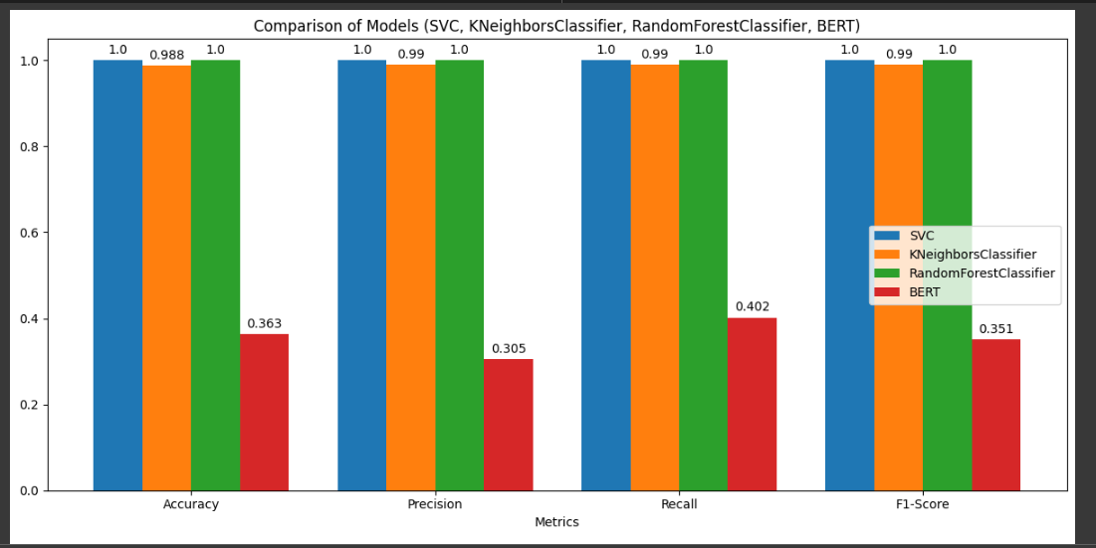

**TABLE:**

| **Model** | **Accuracy** | **Precision** | **Recall** | **F1-Score** | **Loss** |
| --- | --- | --- | --- | --- | --- |
| **SVC (Support Vector Classifier)** | **1.0000** | **1.00** | **1.00** | **1.00** | 0.0000 |
| **KNeighborsClassifier** | 0.9881 | 0.99 | 0.99 | 0.99 | N/A |
| **RandomForestClassifier** | **1.0000** | **1.00** | **1.00** | **1.00** | 0.0000 |
| **BERT (Fine-Tuned)** | 0.3627 | 0.305 | 0.402 | 0.351 | 2.5001 |

**METRICS:**

**BERT MODEL:**

BERT Model Results:

Accuracy: 0.3627

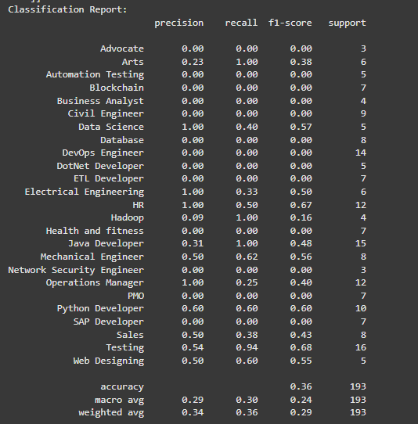

**KNN MODEL:**

KNeighborsClassifier Results:

Accuracy: 0.9881

**SVC MODEL:**

SVC Results:

Accuracy: 1.0000

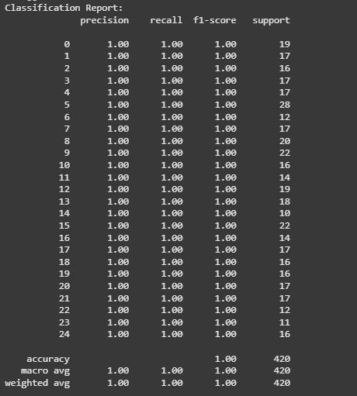

**Random Forest Classifier:**

RandomForestClassifier Results:

Accuracy: 1.0000

